**Ideation Phase**

**Empathize & discover**

|  |  |
| --- | --- |
| Date | 19 September 2023 |
| Team ID | **593090** |
| Project Name | |  | | --- | | TrafficTelligence: Advanced Traffic  Volume Estimation with Machine Learning | |  | |
| Maximum Marks | 4 Marks |

**Empathy Map Canvas:**

The Empathy Map Canvas is a visual tool used in design thinking and customer experience design to understand and empathize with the target audience or users. It is a collaborative exercise that helps teams gain a deeper understanding of the people they are designing for by exploring their thoughts, feelings, actions, and aspirations.

The Empathy Map is particularly useful in the early stages of the design process to create a user-centred focus and to ensure that the resulting product or service addresses the real needs and experiences of the target audience. It promotes empathy, which is essential for creating solutions that genuinely meet the users' needs and expectations.

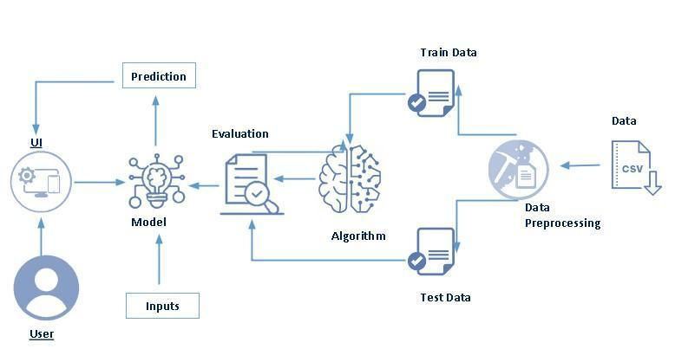

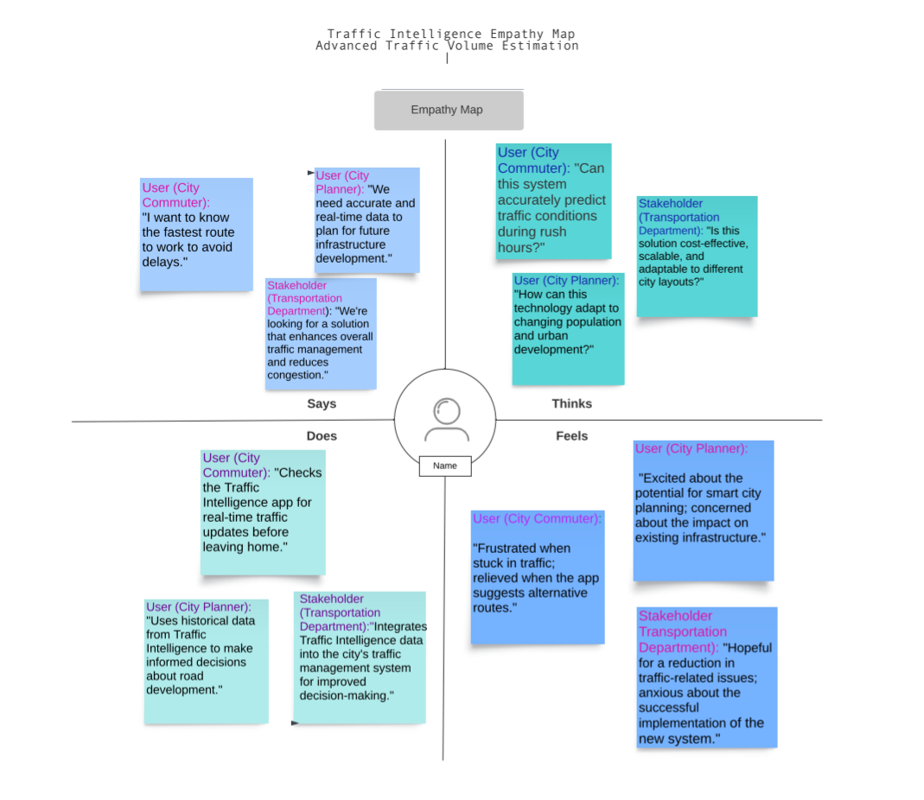

An Empathy mapping canvas includes:

**Users**:

Main user are all citizens.

**Stakeholders:**

there are many stake holders, like:

1.students.

2.employees.

3.senior citizens.

4.childrens.

5.worker

**Activities:**  
The activities which are carried out: -

1.walking.

2.driving.

3.towing vehicles. Etc

Now,

The Empathy Map Canvas typically consists of **four quadrants (Says , Thinks ,Does , Feels)** , each focusing on a different aspect of the user's experience:

Here's an example of how you might fill out each quadrant:

**1. Says:**

User (City Commuter): "I want to know the fastest route to work to avoid delays."

User (City Planner): "We need accurate and real-time data to plan for future infrastructure development."

Stakeholder (Transportation Department): "We're looking for a solution that enhances overall traffic management and reduces congestion."

**2. Thinks:**

User (City Commuter): "Can this system accurately predict traffic conditions during rush hours?"

User (City Planner): "How can this technology adapt to changing population and urban development?"

Stakeholder (Transportation Department): "Is this solution cost-effective, scalable, and adaptable to different city layouts?"

**3. Does:**

User (City Commuter): "Checks the Traffic Intelligence app for real-time traffic updates before leaving home."

User (City Planner): "Uses historical data from Traffic Intelligence to make informed decisions about road development."

Stakeholder (Transportation Department): "Integrates Traffic Intelligence data into the city's traffic management system for improved decision-making."

**4. Feels:**

User (City Commuter): "Frustrated when stuck in traffic; relieved when the app suggests alternative routes."

User (City Planner): "Excited about the potential for smart city planning; concerned about the impact on existing infrastructure."

Stakeholder (Transportation Department): "Hopeful for a reduction in traffic-related issues; anxious about the successful implementation of the new system."